Visual representation of the network of noble families in Florence with no augmentations
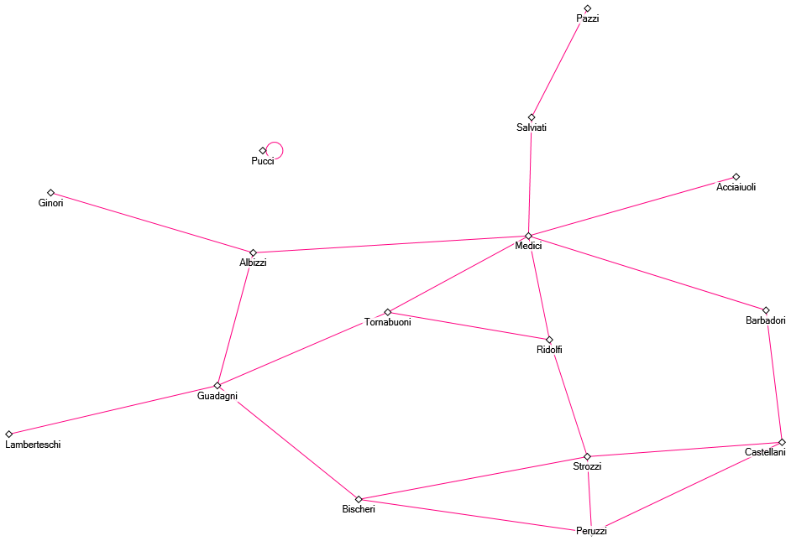
This representation has all of the families connected with no augmentations to show the influence or number of connections with other families. This is just a basic network graph that shows a simple connection between the families in Florence.

Visual representation of the network of noble families in Florence where the degree determines the size of the nodes
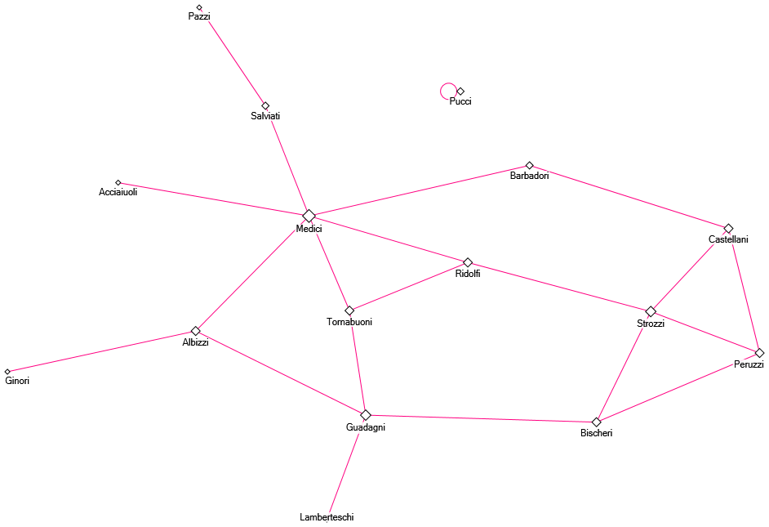
As you can see here, the families that have more degrees will have larger node sizes. This shows how connected each family is and potentially shows how much influence each family has based on those connections.

Visual representation of the network of noble families in Florence if the Medici family didn’t exist
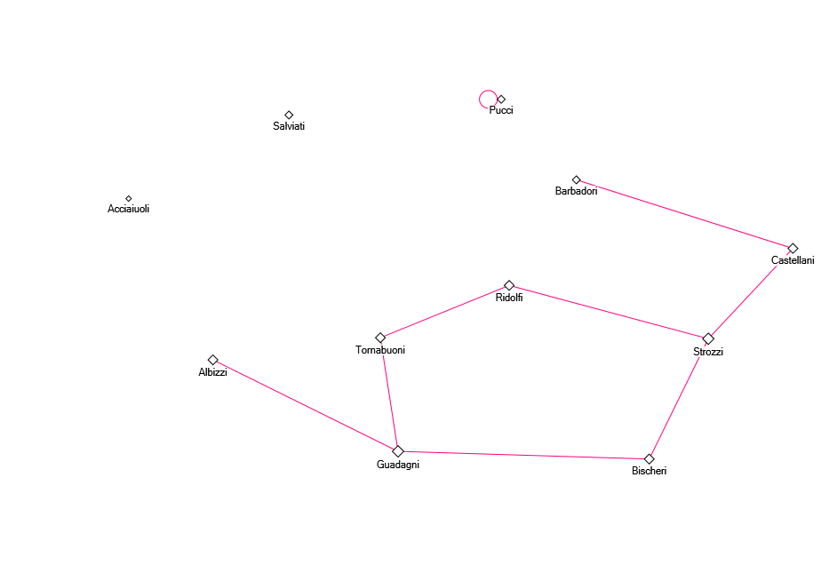
This specific graph includes all of the nodes that have a degree of 5 or less. In this situation, this would represent a world where the Medici family didn’t exist in Florence. We can see that this effects the overall graph by removing 6 edges from the graph. With this family removed, the Acciaiuoli and the Salviati family are no longer connected to the rest of the graph and the other families in theory would lose influence in Florence due to the lack of another powerful family.

Degree Distribution Histogram

Adjacency Matrix
Family | Acciaiuoli | Albizzi | Barbadori | Bischeri | Castellani | Ginori | Guadagni | Lamberteschi | Medici | Pazzi | Peruzzi | Pucci | Ridolfi | Salviati | Strozzi | Tornabuoni
Acciaiuoli | 0 | 0 | 0 | 0 | 0 | 0 | 0 | 0 | 1 | 0 | 0 | 0 | 0 | 0 | 0 | 0
Albizzi | 0 | 0 | 0 | 0 | 0 | 1 | 1 | 0 | 1 | 0 | 0 | 0 | 0 | 0 | 0 | 0
Barbadori | 0 | 0 | 0 | 0 | 1 | 0 | 0 | 0 | 1 | 0 | 0 | 0 | 0 | 0 | 0 | 0
Bischeri | 0 | 0 | 0 | 0 | 0 | 0 | 1 | 0 | 0 | 0 | 1 | 0 | 0 | 0 | 1 | 0
Castellani | 0 | 0 | 1 | 0 | 0 | 0 | 0 | 0 | 0 | 0 | 1 | 0 | 0 | 0 | 1 | 0
Ginori | 0 | 1 | 0 | 0 | 0 | 0 | 0 | 0 | 0 | 0 | 0 | 0 | 0 | 0 | 0 | 0
Guadagni | 0 | 1 | 0 | 1 | 0 | 0 | 0 | 1 | 0 | 0 | 0 | 0 | 0 | 0 | 0 | 1
Lamberteschi | 0 | 0 | 0 | 0 | 0 | 0 | 1 | 0 | 0 | 0 | 0 | 0 | 0 | 0 | 0 | 0
Medici | 1 | 1 | 1 | 0 | 0 | 0 | 0 | 0 | 0 | 0 | 0 | 0 | 1 | 1 | 0 | 1
Pazzi | 0 | 0 | 0 | 0 | 0 | 0 | 0 | 0 | 0 | 0 | 0 | 0 | 0 | 1 | 0 | 0
Peruzzi | 0 | 0 | 0 | 1 | 1 | 0 | 0 | 0 | 0 | 0 | 0 | 0 | 0 | 0 | 1 | 0
Pucci | 0 | 0 | 0 | 0 | 0 | 0 | 0 | 0 | 0 | 0 | 0 | 0 | 0 | 0 | 0 | 0
Ridolfi | 0 | 0 | 0 | 0 | 0 | 0 | 0 | 0 | 1 | 0 | 0 | 0 | 0 | 0 | 1 | 1
Salviati | 0 | 0 | 0 | 0 | 0 | 0 | 0 | 0 | 1 | 1 | 0 | 0 | 0 | 0 | 0 | 0
Strozzi | 0 | 0 | 0 | 1 | 1 | 0 | 0 | 0 | 0 | 0 | 1 | 0 | 1 | 0 | 0 | 0
Tornabuoni | 0 | 0 | 0 | 0 | 0 | 0 | 1 | 0 | 1 | 0 | 0 | 0 | 1 | 0 | 0 | 0

The transposed Adjacency Matrix is the same as the original adjacency matrix due to the fact that the network is undirected and the matrix is symmetric.

Stochastic Matrix
Family | Acciaiuoli | Albizzi | Barbadori | Bischeri | Castellani | Ginori | Guadagni | Lamberteschi | Medici | Pazzi | Peruzzi | Pucci | Ridolfi | Salviati | Strozzi | Tornabuoni
Acciaiuoli | 0 | 0 | 0 | 0 | 0 | 0 | 0 | 0 | 1.0 | 0 | 0 | 0 | 0 | 0 | 0 | 0
Albizzi | 0 | 0 | 0 | 0 | 0 | 0.25 | 0.25 | 0 | 0.25 | 0 | 0 | 0 | 0 | 0 | 0 | 0
Barbadori | 0 | 0 | 0 | 0 | 0.5 | 0 | 0 | 0 | 0.5 | 0 | 0 | 0 | 0 | 0 | 0 | 0
Bischeri | 0 | 0 | 0 | 0 | 0 | 0 | 0.333 | 0 | 0 | 0 | 0.333 | 0 | 0 | 0 | 0.333 | 0
Castellani | 0 | 0 | 0.333 | 0 | 0 | 0 | 0 | 0 | 0 | 0 | 0.333 | 0 | 0 | 0 | 0.333 | 0
Ginori | 0 | 1.0 | 0 | 0 | 0 | 0 | 0 | 0 | 0 | 0 | 0 | 0 | 0 | 0 | 0 | 0
Guadagni | 0 | 0.333 | 0 | 0.333 | 0 | 0 | 0 | 0.333 | 0 | 0 | 0 | 0 | 0 | 0 | 0 | 0.0
Lamberteschi | 0 | 0 | 0 | 0 | 0 | 0 | 1.0 | 0 | 0 | 0 | 0 | 0 | 0 | 0 | 0 | 0
Medici | 0.1667 | 0.1667 | 0.1667 | 0 | 0 | 0 | 0 | 0 | 0 | 0 | 0 | 0 | 0.1667 | 0.1667 | 0 | 0.1667
Pazzi | 0 | 0 | 0 | 0 | 0 | 0 | 0 | 0 | 0.5 | 0 | 0 | 0 | 0 | 0.5 | 0 | 0
Peruzzi | 0 | 0 | 0 | 0.333 | 0.333 | 0 | 0 | 0 | 0 | 0 | 0 | 0 | 0 | 0 | 0.333 | 0
Pucci | 0 | 0 | 0 | 0 | 0 | 0 | 0 | 0 | 0 | 0 | 0 | 0 | 0 | 0 | 0 | 0
Ridolfi | 0 | 0 | 0 | 0 | 0 | 0 | 0 | 0 | 0.333 | 0 | 0 | 0 | 0 | 0 | 0.333 | 0.333
Salviati | 0 | 0 | 0 | 0 | 0 | 0 | 0 | 0 | 0.5 | 0.5 | 0 | 0 | 0 | 0 | 0 | 0
Strozzi | 0 | 0 | 0 | 0.333 | 0.333 | 0 | 0 | 0 | 0 | 0 | 0.333 | 0 | 0.333 | 0 | 0 | 0
Tornabuoni | 0 | 0 | 0 | 0 | 0 | 0 | 0.5 | 0 | 0.5 | 0 | 0 | 0 | 0.0 | 0 | 0 | 0

For this stochastic matrix, the numbers represent a fraction of the total connections that go from one family to another. For example, the Medici family is married into 6 other families, and therefore 1 family is attached to 6 others. With this in mind, to find the values, we divide 1 by 6 and get 0.1667 as the value. This applies to all other families in this table. The point of the stochastic matrix is to show the transition possibilities from one family to another if you want to use a random walk interpretation.

Diameter (Longest Geodesic)
From \ To | Acciaiuoli | Albizzi | Barbadori | Bischeri | Castellani | Ginori | Guadagni | Lamberteschi | Medici | Pazzi | Peruzzi | Pucci | Ridolfi | Salviati | Strozzi | Tornabuoni
Acciaiuoli | 0 | 2 | 2 | 2 | 3 | 3 | 2 | 3 | 1 | 2 | 3 | ∞ | 2 | 2 | 3 | 2
Albizzi | 2 | 0 | 2 | 2 | 3 | 1 | 1 | 2 | 1 | 1 | 3 | ∞ | 2 | 1 | 2 | 2
Barbadori | 2 | 2 | 0 | 3 | 1 | 2 | 3 | 3 | 1 | 2 | 2 | ∞ | 1 | 2 | 2 | 2
Bischeri | 2 | 2 | 3 | 0 | 2 | 3 | 1 | 2 | 2 | 3 | 1 | ∞ | 1 | 3 | 1 | 2
Castellani | 3 | 3 | 1 | 2 | 0 | 3 | 3 | 3 | 2 | 3 | 1 | ∞ | 2 | 3 | 1 | 3
Ginori | 3 | 1 | 2 | 3 | 3 | 0 | 2 | 3 | 2 | 2 | 3 | ∞ | 3 | 2 | 3 | 3
Guadagni | 2 | 1 | 3 | 1 | 3 | 2 | 0 | 1 | 2 | 2 | 3 | ∞ | 2 | 2 | 2 | 1
Lamberteschi | 3 | 2 | 3 | 2 | 3 | 3 | 1 | 0 | 3 | 3 | 4 | ∞ | 3 | 3 | 3 | 2
Medici | 1 | 1 | 1 | 2 | 2 | 2 | 2 | 3 | 0 | 1 | 3 | ∞ | 1 | 1 | 2 | 1
Pazzi | 2 | 1 | 2 | 3 | 3 | 2 | 2 | 3 | 1 | 0 | 3 | ∞ | 2 | 1 | 3 | 2
Peruzzi | 3 | 3 | 2 | 1 | 1 | 3 | 3 | 4 | 3 | 3 | 0 | ∞ | 2 | 3 | 1 | 3
Pucci | ∞ | ∞ | ∞ | ∞ | ∞ | ∞ | ∞ | ∞ | ∞ | ∞ | ∞ | 0 | ∞ | ∞ | ∞ | ∞
Ridolfi | 2 | 2 | 1 | 1 | 2 | 3 | 2 | 3 | 1 | 2 | 2 | ∞ | 0 | 2 | 2 | 1
Salviati | 2 | 1 | 2 | 3 | 3 | 2 | 2 | 3 | 1 | 1 | 3 | ∞ | 2 | 0 | 3 | 2
Strozzi | 3 | 2 | 2 | 1 | 1 | 3 | 2 | 3 | 2 | 3 | 1 | ∞ | 2 | 3 | 0 | 2
Tornabuoni | 2 | 2 | 2 | 2 | 3 | 3 | 1 | 2 | 1 | 2 | 3 | ∞ | 1 | 2 | 2 | 0

For the Diameter, we are determining the shortest path lengths between all of the families. In this case, the Pucci family is isolated, so they are listed as infinity. All of the other families are at least connected to another family. Families can not connect to themselves in this context so Distance to self is equal to 0. The diameter of this network is 4 because that is the largest number of steps in this network. The connection that creates that largest step number is Lamberteschi to Peruzzi.

Centralities
Degree Centrality
Family Name | Degree Centrality
Medici | 6
Guadagni | 4
Strozzi | 4
Albizzi | 3
Tornabuoni | 3
Ridolfi | 3
Castellani | 3
Bischeri | 3
Peruzzi | 3
Pucci | 2
Salviati | 2
Barbadori | 2
Pazzi | 1
Ginori | 1
Lamberteschi | 1
Acciaiuoli | 1

The degree centrality is a simple measure that quantifies the popularity of a node. This is shown by the number of degrees that each node has. The Medici family has the highest Degree Centrality because it has the highest number of connections with other families. Because this is an undirected network, the degree centrality is simply just the number of connections a node has.

Betweenness Centrality
Family Name | Betweenness Centrality
Medici | 47.500
Guadagni | 23.167
Albizzi | 19.333
Salviati | 13.000
Ridolfi | 10.333
Bischeri | 9.500
Strozzi | 9.333
Barbadori | 8.500
Tornabuoni | 8.333
Castellani | 5.000
Peruzzi | 2.000
Acciaiuoli | 0.000
Lamberteschi | 0.000
Pazzi | 0.000
Ginori | 0.000
Pucci | 0.000

Betweenness Centrality is the measure of how often the node appears to bridge connections between other nodes. In this case, the Medici family has the highest score due to the fact that the Medici family has more marriage connections than any other family.
Closeness Centrality
Family Name | Closeness Centrality
Medici | 0.040
Ridolfi | 0.036
Albizzi | 0.034
Tornabuoni | 0.034
Guadagni | 0.033
Strozzi | 0.031
Barbadori | 0.031
Bischeri | 0.029
Salviati | 0.028
Castellani | 0.028
Peruzzi | 0.026
Acciaiuoli | 0.026
Ginori | 0.024
Lamberteschi | 0.023
Pazzi | 0.020
Pucci | 0.000

The Closeness Centrality sorts the families based on the proximity to other nodes that are present in the network. The higher the number, the closer the families are to other nodes. Families such as the Medici, Ridolfi and Tornabuoni family have the highest closeness centrality because they are closer to the center of the graph and have the most proximity to other families.

Eigenvector Centrality
Family Name | Eigenvector Centrality
Medici | 0.123
Strozzi | 0.102
Ridolfi | 0.098
Tornabuoni | 0.093
Guadagni | 0.083
Bischeri | 0.081
Peruzzi | 0.079
Castellani | 0.074
Albizzi | 0.070
Barbadori | 0.060
Salviati | 0.042
Acciaiuoli | 0.038
Lamberteschi | 0.025
Ginori | 0.021
Pazzi | 0.013
Pucci | 0.000

The Eigenvector Centrality is a way to show the relationship between other prominent families. This metric tracks the connection between nodes who are themselves connected to other well-connected families. The higher the value, the more connections with better connected families. In this case, the Medici family holds the

PageRank Centrality
Family Name | PageRank Centrality
Medici | 2.187
Guadagni | 1.476
Strozzi | 1.321
Albizzi | 1.187
Tornabuoni | 1.069
Ridolfi | 1.044
Castellani | 1.040
Bischeri | 1.033
Peruzzi | 1.018
Pucci | 1.000
Salviati | 0.920
Barbadori | 0.754
Pazzi | 0.541
Ginori | 0.486
Lamberteschi | 0.464
Acciaiuoli | 0.460

The PageRank Centrality is a way to show who the most important families in the network are. In this case, because the Medici family have the most links leading to them from other families, they are leading the rest of the families in this metric.

Summary
In this case, we get to look at the relationships between the major families of Florence. The popularity of these families, or the number of connections between families, shows how influential they are in this society. Families with higher numbers of connections will have greater pull. The Medici for example is the most influential family due to their 6 connections with other families. This creates cliques where certain families stick together on the graph. Some families themselves are outside looking in. Some of the families actually gained influence without having to be in proximity to other families in this network. While the Medici family has the most networking with others, the Albizzi family became an economic powerhouse despite lacking external connections. Some other families, for example the Strozzi family, have created their own clique outside of the Medici family clique by accruing the most wealth and council outside of the Medici connections. This proves that while family connections can bring influence, it is not fully necessary to be attached to other families to get some level of influence or power.

